Zachary Frye
CSC 500
Assignment 1
1/18/2026
Pseudocode:
Part 1:
- Start
- Prompt user to input a number
- Store the first number (user_num1)
- Prompt for second number
- Store the second number (user_num2)
- Print the sum of the two numbers and retrieve input
- Print the difference of the two numbers and retrieve input
- End
Part 2:
- Start
- Prompt user to input a number
- Store the first number (user_num1)
- Prompt for second number
- Store the second number (user_num2)
- Print the product of the two numbers and retrieve input
- Print the division of the two numbers and retrieve input
- End

Source Code:
# Zachary Frye
# CSC 500
# Assignment 1 - Part 1

print('Hello! Please input a number:')
user_num1 = int(input()) #prompt and get first number
print('Please input a second number:')
user_num2 = int(input()) #prompt and get second number
print()
sum = user_num1 + user_num2 #sum two numbers together
diff = user_num1 - user_num2 #subtract two numbers
print('The sum of', user_num1, 'and', user_num2, 'is:', sum) # output results
print('The difference of', user_num1, 'and', user_num2, 'is:', diff)
# Zachary Frye
# CSC 500
# Assignment 1 - Part 2

print('Hello! Please input a number:')
user_num1 = int(input()) #prompt and get first number
print('Please input a second number:')
user_num2 = int(input()) #prompt and get second number
print()
prod = user_num1 * user_num2 #sum two numbers together
div = user_num1 / user_num2 #subtract two numbers
print('The product of', user_num1, 'and', user_num2, 'is:', prod) # output results
print('The division of', user_num1, 'and', user_num2, 'is:', div)

Results:
Part 1:
Hello! Please input a number:
6
Please input a second number:
7

The sum of 6 and 7 is: 13
The difference of 6 and 7 is: -1

Part 2:
Hello! Please input a number:
289
Please input a second number:
17

The product of 289 and 17 is: 4913
The division of 289 and 17 is: 17.0

Screenshots:
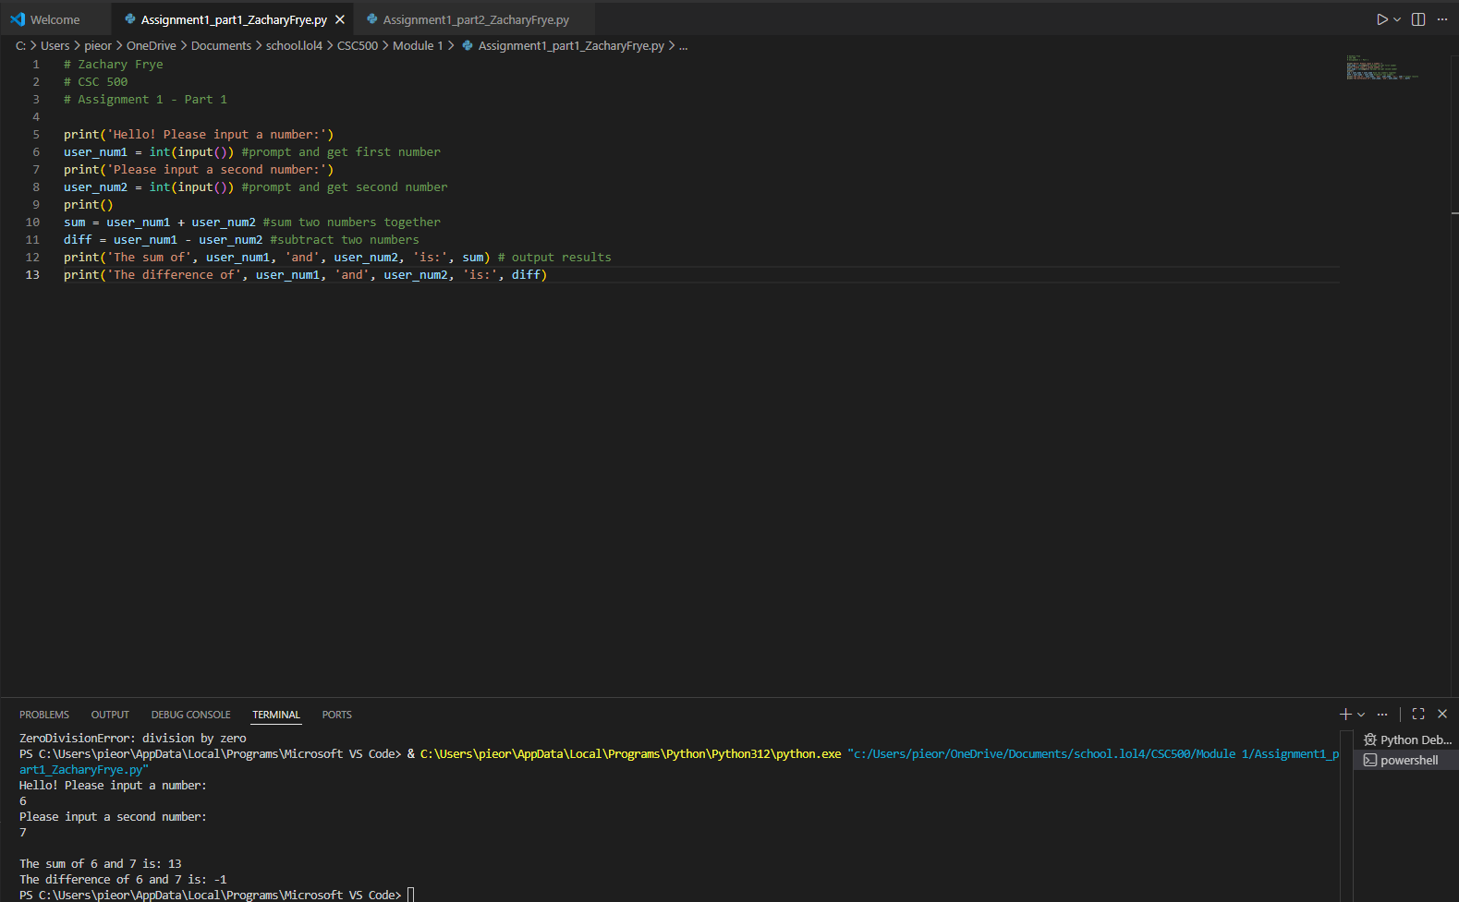
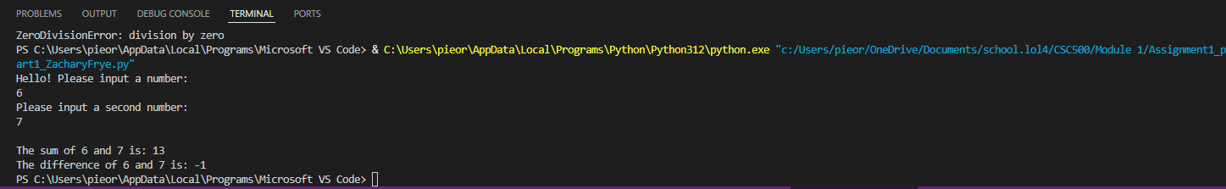
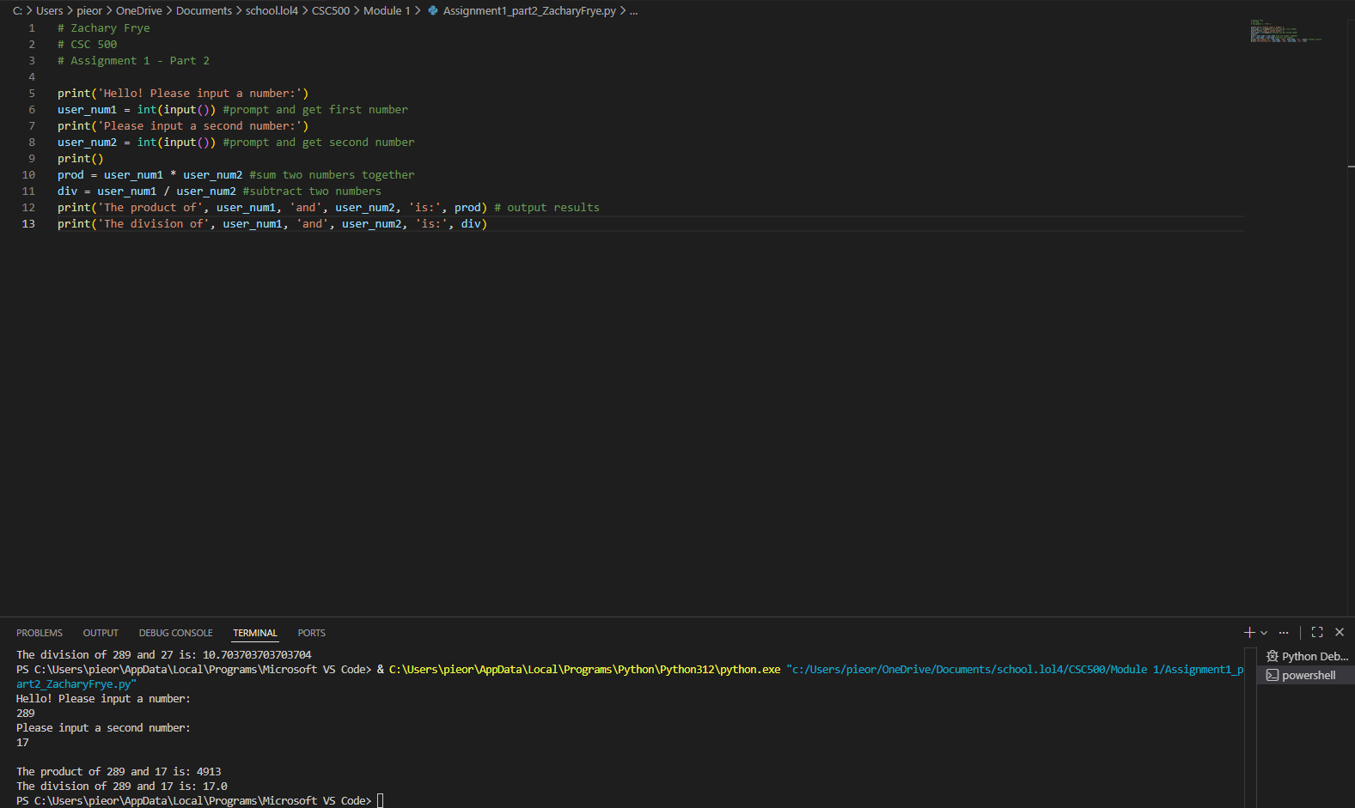
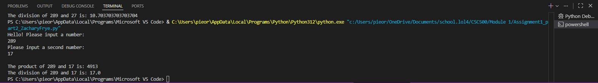
Git repository:

